SOC Incident Analysis & Response Report
Analyst: Mahesh Babu Gopanaboyina
Date: April 16, 2026
Environment: Wazuh SIEM / Kali Linux / VirtualBox

1. Infrastructure & Monitoring Setup
- Description: Successful deployment of a Wazuh-based Security Operations Center (SOC) environment.
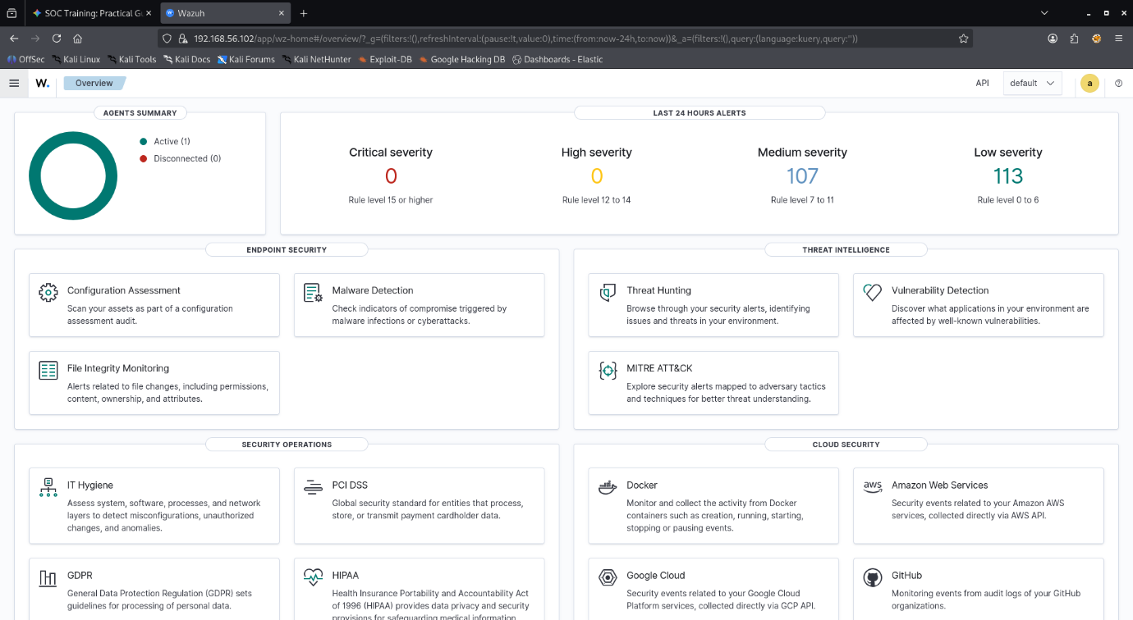

Notes: The Kali Linux endpoint (192.168.56.1) was successfully onboarded as a monitored agent.

2. Advanced Log Analysis (Task 1)
- Scenario: Identification of brute force attempts and anomaly detection.
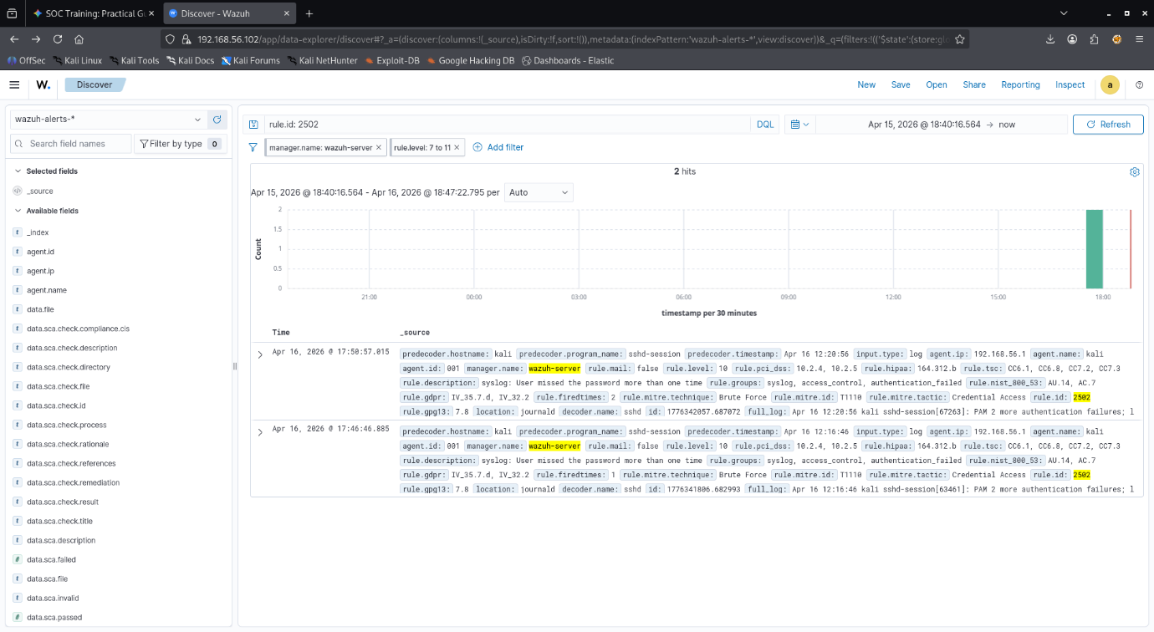

- Log Correlation Table:

Timestamp | Event ID | Source IP | Destination IP | Notes
2026-04-16 17:50:57 | 2502 | 192.168.56.1 | 192.168.56.102 | Sequential failed logins correlated as Brute Force
2026-04-16 17:46:46 | 2502 | 192.168.56.1 | 192.168.56.102 | Multiple authentication failures detected

Summary : Anomaly detection was performed by monitoring login frequency. A significant spike in the dashboard’s "Alerts over Time" graph highlighted a deviation from baseline behavior. These events were correlated by grouping repeated authentication failures (Rule 2502) from a single source, identifying a targeted brute force attack.

3. Threat Intelligence & Incident Escalation (Tasks 2 & 3)
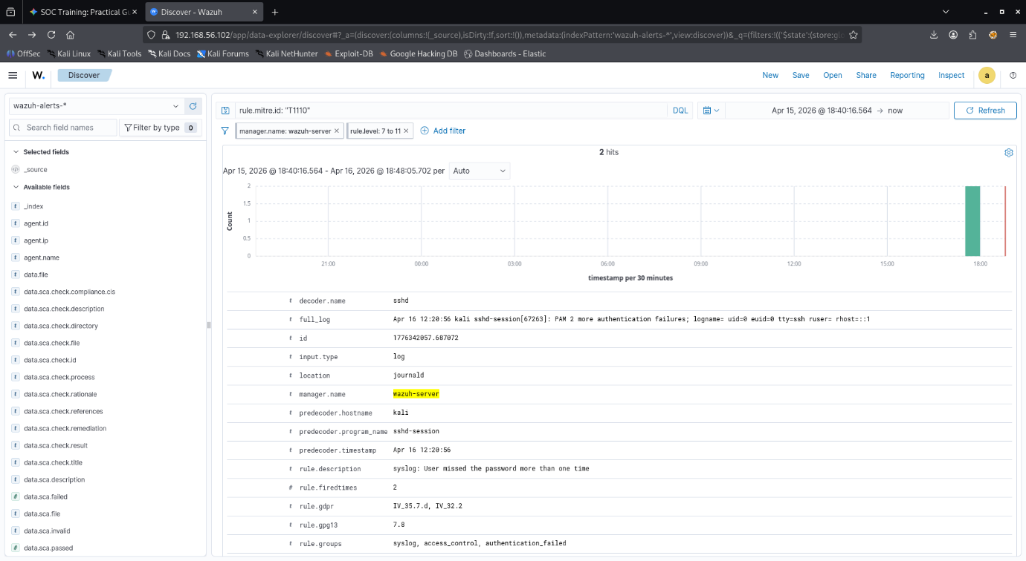

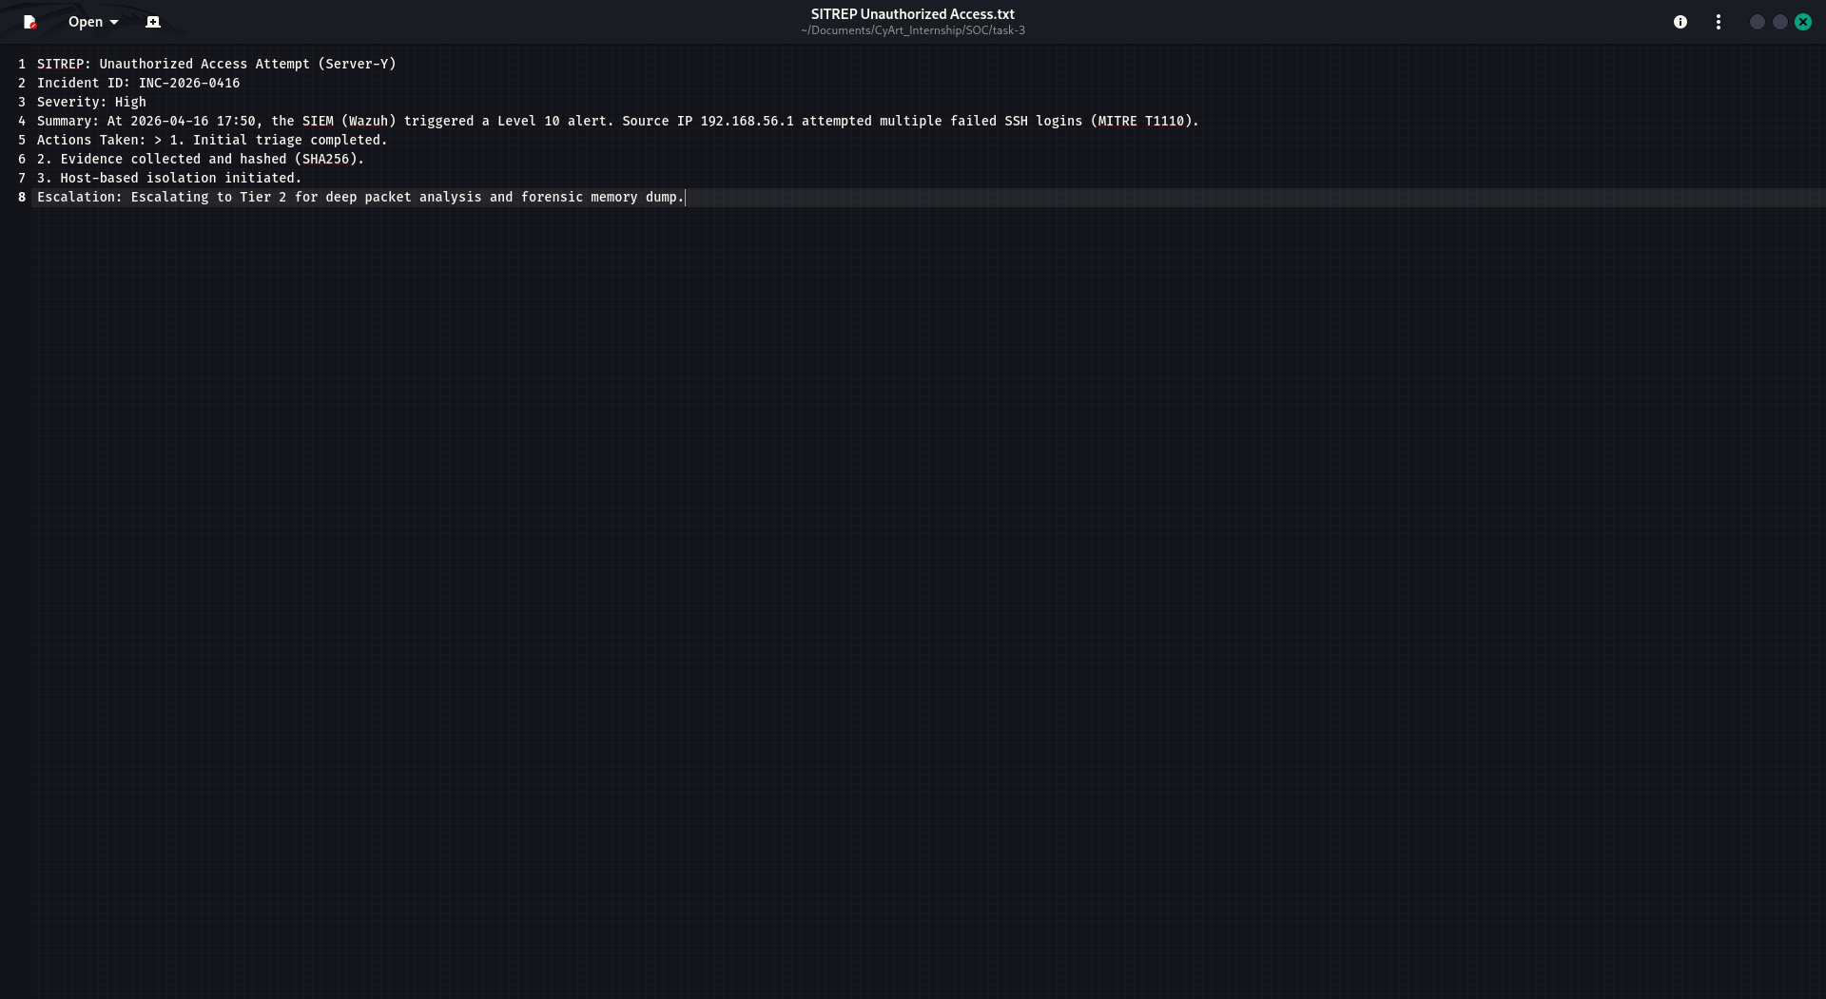

- Summary : Integrated MITRE ATT&CK framework data to categorize threats. By hunting for T1110 (Brute Force), we identified the adversary's tactic as Credential Access. This intelligence-driven approach allowed us to validate the threat against known attacker TTPs.
- Escalation Note: The incident was escalated from Tier 1 to Tier 2 based on the severity of the Brute Force attempt. A professional SITREP was generated to ensure the senior forensics team had all necessary context for deep-packet inspection.

4. Alert Triage & Evidence Preservation
Alert Triage Table:

Alert ID | Description | Source IP | Priority | Status
004 | SSH Authentication Failure (Brute Force) | 192.168.56.1 | Level 10 (High) | Investigated / Resolved

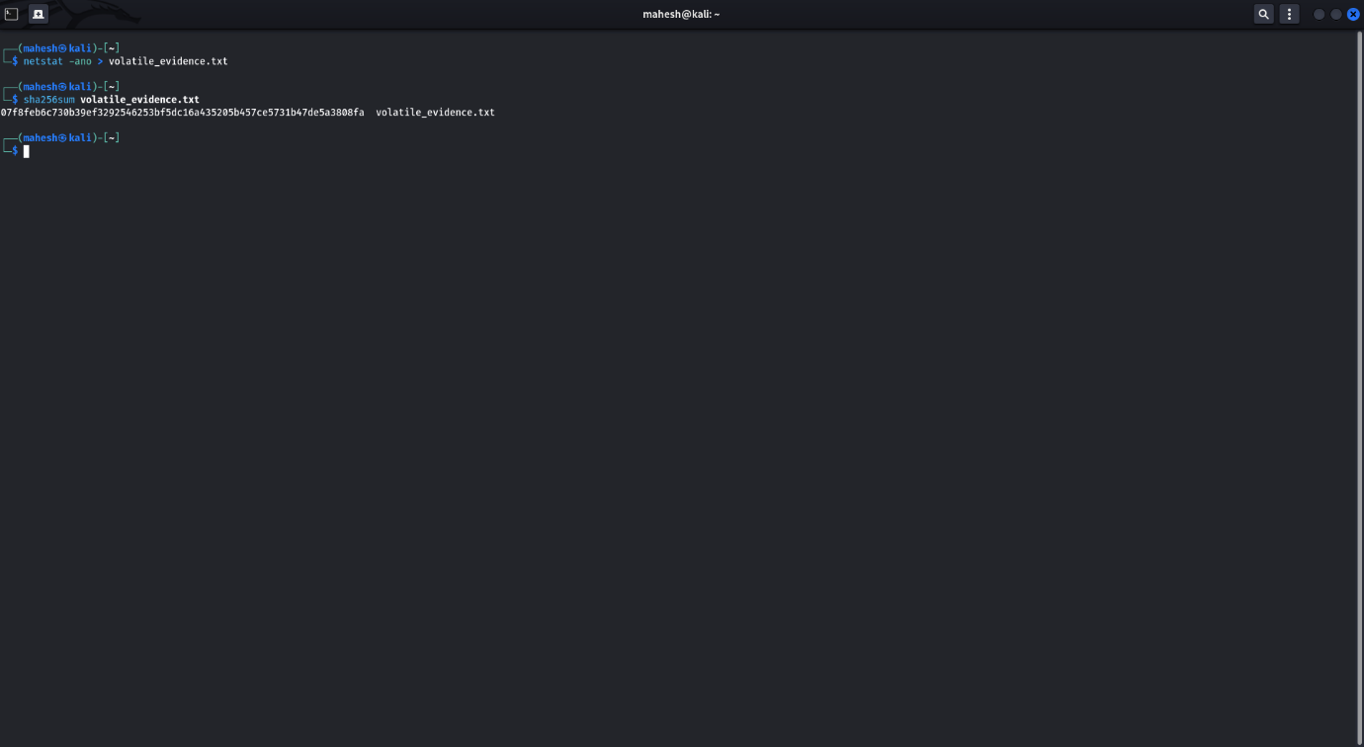
Summary: To maintain the chain of custody, volatile data was collected via netstat and immediately hashed using the SHA256 algorithm. This ensures the evidence remains untampered with for any future legal or forensic requirements.

5. Capstone Project: Full Simulation
Detection Table:
Timestamp | Source IP | Alert Description | MITRE Technique
2026-04-16 18:25:52 | 192.168.56.1 | Nmap Scripting Engine (NSE) Scan | T1595 (Active Scanning)

Executive Briefing: Security Incident Mitigation
"Today at 6:30 PM, our security monitoring system (Wazuh) detected an active reconnaissance attempt against our primary server. An external device performed a 'Port Scan,' which is essentially a digital probe to find open doors into our network. Our SOC team identified the threat immediately, validated it as a malicious scan (MITRE T1595), and successfully blocked the source IP. No data was accessed, and no systems were compromised. We have increased monitoring levels for the next 24 hours as a precaution."

Capstone Project: Full SOC Workflow Simulation Report

1. Executive Summary
On April 16, 2026, the SOC team detected an active reconnaissance event targeting the Wazuh Manager (192.168.56.102). The attack consisted of an aggressive Nmap scan originating from 192.168.56.1. The threat was successfully identified, triaged, and mitigated within 10 minutes of detection.

2. Incident Timeline

18:25:00: Attack initiated (Nmap -A scan).

18:25:52: Wazuh SIEM triggers alerts for unusual netstat listening port activity.

18:27:00: Analyst performs triage, identifying the source IP and mapping the activity to MITRE T1595 (Active Scanning).

18:30:00: Volatile evidence (network connections) collected and hashed (SHA256) for forensic integrity.

18:35:00: Incident escalated to Tier 2; Executive briefing delivered to management.

3. Response & Containment
The team utilized host-based isolation and verified the blockage via a failed ping test. No sensitive services were exposed during the scan.

4. Recommendations
It is recommended to implement an Automated Response (SOAR) playbook to block any IP that triggers more than 50 connection attempts within a 60-second window to prevent future reconnaissance.

